

Mr. **M . RAMASWAMY   
S/o** M Muni Yellappa   
**"AKSHAYA GOLD APARTMENT"**No.14, 27th Main, 4th Cross, Ejipura,   
VGS Layout, Viveknagar Post,   
Bangalore - 560 047.



fgt., -0. Certificate No.

Certificate Issued Date Account Reference Unique Doc. Reference

* **10 iv;** Purchased by

Description of Document Description

Consideration Price (Rs.)

tit

First Party

Second Party

Stamp Duty Paid By

Stamp Duty Amount(Rs.)

**INDIA NON JUDICIAL**

**Government of Karnataka**

**e-Stamp**

IN-KA066976377365370

15-Dec-2018 02:29 PM

NONACC (Fly kacrs1108/ KORAMANGALA5/ KA-BA

SUBIN-KAKACRSFLO8491009793456660

SWARNAM PANDAY

Article 30 Lease of Immovable Property

RENTAL AGREEMENT

0

(Zero)

M RAMASWAMY

SWARNAM PANDAY

SWARNAM PANDAY

50

(Fifty only)



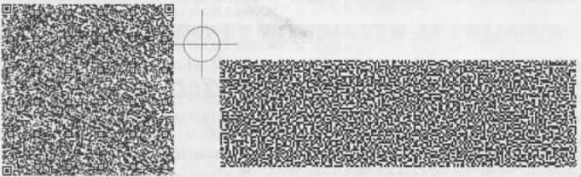

Please write or type below this line

**RENTAL AGREEMENT**

THIS **RENTAL AGREEMENT** is made and executed on this the 15th day of December 2020 at Bangalore by and between:-

Statutory Alert: Page 1 of **3**

**I** The authenticity al this Stamp Certificate should be verified at -www.shcilestainp aim' Any disoepency in Ow details on this CerlifiE,,k,

available on the website renders ft invalid

2 Tne onus of cneckmg the legitimacy is on the users of the certificate

3 In case of any discrepancy please inform the Competent Authority



|  |  |
| --- | --- |
| W3Vetz ant:  **Document Sheet**  1 |  |

Hereinafter referred referred to as the **"OWNER / LESSOR"** of the **ONE PART,**

|  |  |  |
| --- | --- | --- |
| **Mr. SWARNAM PANDAY**  Permanent address  245 S block Yashoda Nagar,  Kanpur,  Kanpur - 208011. |  |  |

Hereinafter referred to as the **"TENANT/LESSEE"** of the **OTHER PART.**

Whereas the term shall mean and include the Lessor and Lessee and their legal heirs, legal representatives, assigness, assignors, administrators, attorney and executors etc.), WITNESSETHAS FOLLOWS:

**NOW THIS AGREEMENT WITNESSETH AS FOLLOWS:**

1. The Tenancy is for a period of 11 months, commenced from **1st day of December 2020** which shall be continued by **5%** increment in existing rent.
2. The Lessee has agreed to pay the monthly rent of **Rs.8,000/-(Rupees Eight Thousand only)** per month to the scheduled premises and payable on or before every 5th day of each succeeding English calendar month.
3. The Lessee has paid an advance amount of **Rs.40,000/- (Rupees Forty thousand only)** to the Lessor before the following witness. The advance amount will be refundable by the Lessor to the Lessee at the time of Lessee vacating the schedule premises without adding any type of interest.
4. The Lessee shall make use of the premises for **RESIDENTIAL PURPOSE** only and whereas they should not Carry any unlawful activities in the said premises.

Page 2 of **3**

1. The Lessee shall not **sub-let, assign, underlet** or do any alterations, or put any permanent structures without prior permission from the Lessor.
2. The Lessee during the period of Tenancy shall keep the premises in **neat and good** and tenantable condition subject to normal wear and tear.
3. The Lessor is at **full liberty to inspect** the schedule premises at reasonable hours, for which the Lessee has no objection.
4. Either Party should give in writing **60 days (2 Months)** prior notice to vacating the schedule premises during the period of lease.
5. The Lessee shall pay **ELECTRICITY CHARGES** to the concerned authorities as per bill issued by the authority without accumulating the arrears.
6. The Lessees shall pay **painting and maintenance charges** one month rent or the same amount will be deducted from the security deposit at the time of vacating the schedule premises.

**SCHEDULE**

All that piece and parcel of premises bearing **"Akshaya Gold Apartment"„ No.14, Flat No.401, 27th Main, 4th Cross, Ejipura, VGS Layout, Viveknagar Post, Bangalore — 560 047.** Consisting of Two Bedrooms, One Hall, One Kitchen, Two bathrooms and Toilet with water, Sanitary and electricity facilities.

**Fittings Fixtures**

|  |  |  |  |
| --- | --- | --- | --- |
|  | Ceiling fan | : | 3 Nos. |
|  | Tube Lights | : | 3 Nos. |
|  | Geyser | : | 2 Nos. |

**IN WITNESS WHEREOF,** both the parties have signed to this Rental Agreement, on the day, month and year first above written in the presence of the following witness.

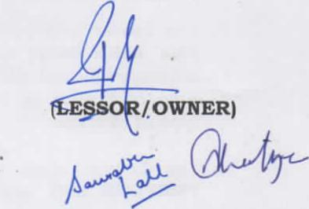

**/ OWNER)**

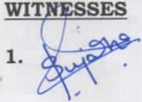

**(LESSEE/TENANT)**

**2.**

Page 3 of 3